

Looking to join

Romafire & First Aid “Romafire”

“If you think you can, you’re right. And if you think you can’t, you’re also right.” – Henry Ford





In this section:

* Personal and Business Goals
* SMART Goals
* Business Challenges

My Goals

Worksheet

A guide to setting achievable personal goals and career goals

**GOALS WORKSHEET**

It is important you put some thought into your answers and be as specific as you can.

Name: __________________________________________________________________________

# YOUR PERSONAL GOALS

1. What are your personal goals, in other words what do you want to achieve out of life?

(When answering this question consider the things you want to do, the places you want to go and the experiences you want to have in your life – eg: travel, events, hobbies, important people in your life, health, family and friends as well as the physical things, toys and ‘stuff’ – eg: houses, cars, boats, gadgets, jewellery, furniture, art, clothes, investments etc)

_________________________________________________________________

_________________________________________________________________

_________________________________________________________________

_________________________________________________________________

_________________________________________________________________

1. How do you see yourself achieving these goals?

_________________________________________________________________

_________________________________________________________________

_________________________________________________________________

_________________________________________________________________

# YOUR CAREER GOALS

Now that you are clear on what you want personally from life, I want you to now think about your career and how this will contribute to achieving your personal goals …

1. So, tell me, why do you want to work with this company in the first place?

______________________________________________________________

______________________________________________________________

______________________________________________________________

1. What do you hope to achieve, what are your goals and ambitions?

_______________________________________________________________

_______________________________________________________________

_______________________________________________________________

1. How many of those goals have been realised in the time you’ve been working?

______________________________________________________________

______________________________________________________________

______________________________________________________________

1. Considering this, what are your goals NOW for your career?

(When answering this question consider things like your vision – eg: what does your career stand for, what do you want your career to be recognised for?

______________________________________________________________

______________________________________________________________

______________________________________________________________

______________________________________________________________

______________________________________________________________

______________________________________________________________

______________________________________________________________

**DEVELOPING SMART GOALS**

SMART is a system designed to give you the best chance of achieving your goals. SMART goals prevent you from creating goals that are too “soft and fluffy”. It stands for:

* Specific
* Measurable
* Achievable
* Realistic
* Timebound

These are key things you should keep in mind when setting goals to make sure you’re setting them correctly from the start. Please aim to make your goals “SMART” when setting your goals in this section.

Here are some examples to get you thinking:

* To consolidate $20,000 debt by February 2022
* To pay off the mortgage by the Year 2030
* To win Employee of the Year 2021
* To lose 12 kg and run a half marathon under 4 hours.
* To have 3 weeks holiday and drop the kids to school two days a week.

Now, being as SMART as you possibly can, what are the 4 goals you want to achieve in your career and your 1 goal you want to achieve in your personal life?

1. _________________________________________________________________
2. __________________________________________________________________
3. __________________________________________________________________
4. __________________________________________________________________
5. __________________________________________________________________

# 

# 

# 

# YOUR CHALLENGES – GOOD AND BAD

# Thanks for that information. That will give us a lot better idea of what you’re looking for out of your career, and life. So now can you tell me …

1. What do you feel you are good at, what do you do that no one else does?

__________________________________________________________________

__________________________________________________________________

__________________________________________________________________

2. What do you feel you do poorly, or you could do better at?

__________________________________________________________________

__________________________________________________________________

__________________________________________________________________

3. Do you have any current challenges you are dealing with now?

__________________________________________________________________

__________________________________________________________________

__________________________________________________________________

__________________________________________________________________

4. If there was just one thing we could do for you right now, what would it be?

______________________________________________________________

______________________________________________________________

_____________________________________________________________

______________________________________________________________

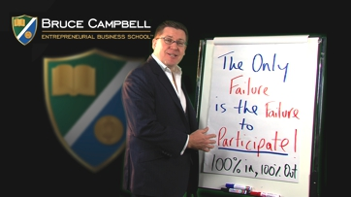



What you’ll need for this section:

* An open mind
* Access to You Tube to watch these videos

**GENERALISED PRINCIPLE 1:**

**PARTICIPATE**

Before starting this section, please Click this Link and watch: <https://youtu.be/clhKp8icsbo>

I need your agreement that you will participate 100%. I need your permission to hold you accountable for participating 100%.

Question: Name a time in your career and/or life where you didn’t participate at 100% and had a less favourable result:

_________________________________________________________________

_________________________________________________________________

_________________________________________________________________



**GENERALISED PRINCIPLE 2:**

**“I KNOW”**



TO MAKE SURE YOU GET THE   
MOST OUT OF YOUR LEARNING:

**I**

**KNOW**

Before starting this section, please Click this Link and watch: <https://youtu.be/nPkD-UjUDDk>

Throughout your employment, you’ll be challenged on things that you don’t know. “What got you to here, won’t get you to there”

Question: Name a time where you thought you were 100% right, only to find out at a later time you were wrong:

___________________________________________________________________

___________________________________________________________________

___________________________________________________________________

**GENERALISED PRINCIPLE 3:**

**NO MORE ‘BUT’S’**

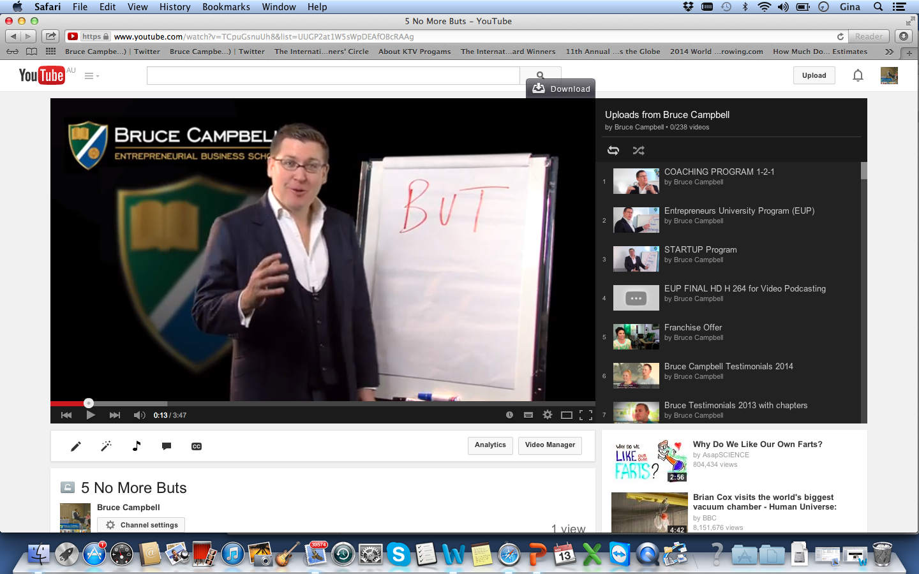

Before starting this section, please Click this Link and watch: <https://youtu.be/TCpuGsnuUh8>

Question: Are you “flat lined”? Name the last time you said “but” – and where you could have used positive phrasing to increase your triangle of possibility.

___________________________________________________________________

___________________________________________________________________

___________________________________________________________________

___________________________________________________________________

___________________________________________________________________

Train yourself to eliminate the word ‘but’ from your vocabulary!

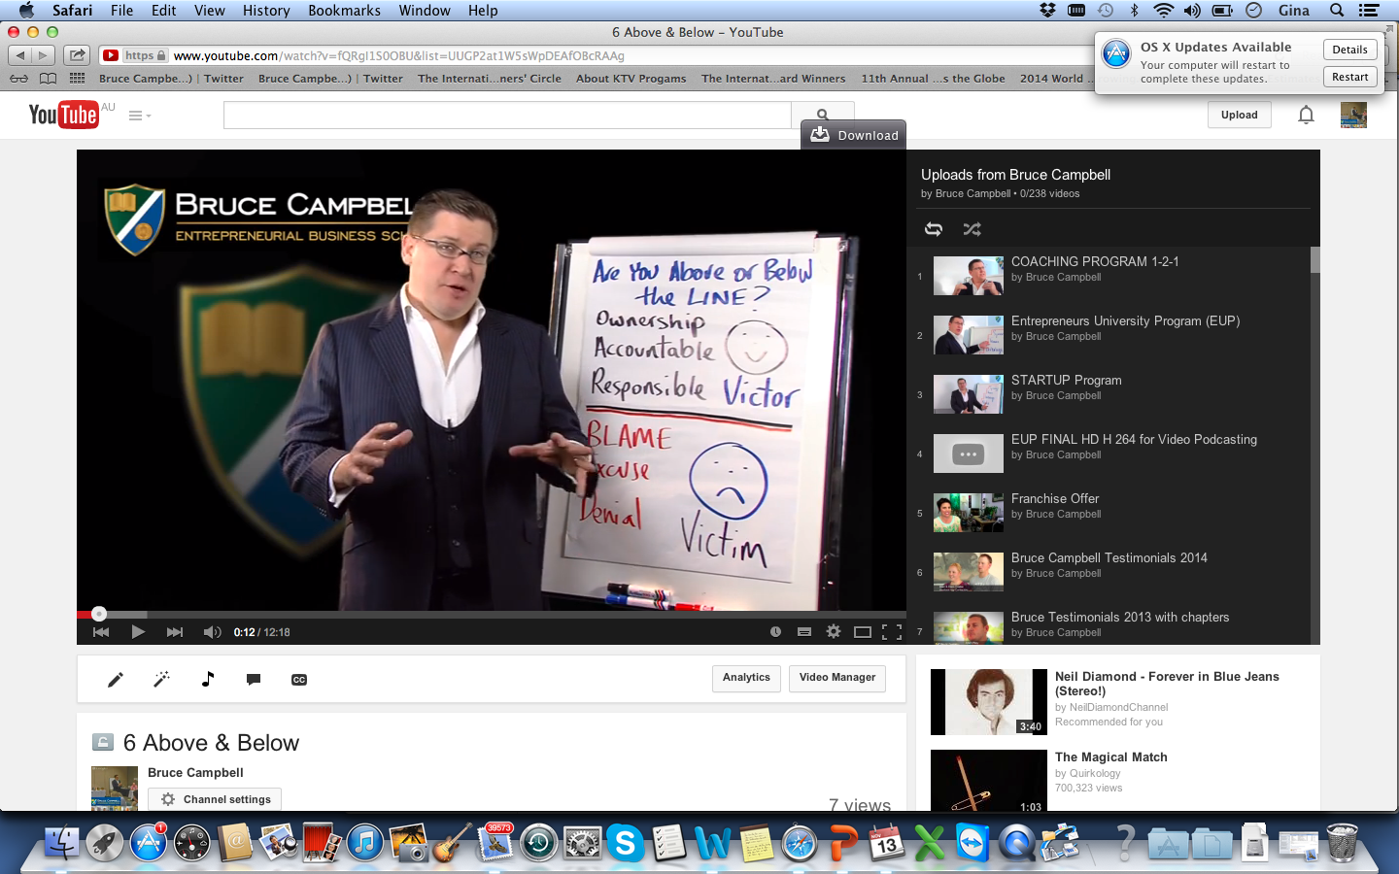

**GENERALISED PRINCIPLE 4:**

**ABOVE & BELOW THE LINE**

Before starting this section, please Click this Link and watch: <https://youtu.be/fQRgI1S0OBU>

The most common challenge that arises in relationships is going off the rails because of unhelpful mental attitudes. It is for this reason that the issue is raised even before we get started.

There is one important rule that we must all comply with:

Play above the line at all times!

## 

Above the line, you own the ship and have an OAR to steer it. Below the line, you make your BED and you must lie in it. By playing above the line, we take ownership of what is happening around us and accept the responsibility and accountability that goes with it.

When something goes wrong, the easiest thing to do is to blame it on somebody else, find an excuse or deny that there is a problem. This ‘playing below the line’ is destructive, as it does not resolve anything and problems get worse. This type of reaction is typical of the victim mentality - failure is a self-fulfilling prophecy for people who think like this. Playing above the line is constructive because taking ownership of, and responsibility for, challenges leads to resolution of problems. It also ensures that they don’t happen again. This pro-active approach is typical of people with a victor mentality. Team members need to commit to playing above the line at all times.

You must decide which line you want to play:

Victor Mentality

------------ VS. ------------

Victim Mentality

BELOW THE LINE

|  |  |
| --- | --- |
| It’s completely natural for all humans to exhibit ‘Below The Line’ behaviours in business.  Please provide examples of times you’ve exhibited Below the Line behaviours in your career: | |
| BLAME |  |
| EXCUSES |  |
| DENIAL |  |

Question: Out of these 3 Below The Line behaviours, which one do you tend to exhibit the most?

___________________________________________________________________

___________________________________________________________________

___________________________________________________________________

ABOVE THE LINE

Playing Above The Line can change things dramatically. Here are some questions to answer:

|  |  |  |
| --- | --- | --- |
|  | QUESTION | ANSWER |
| OWNERSHIP | What do you need to take more ownership of in your career/your life? |  |
| ACCOUNTABLE | Where do you need to take more accountability in your life? |  |
| RESPONSIBLE | By habit, do you choose positively or negatively most of the time? |  |

Question: Which ‘Above The Line’ behaviours would you like to get better at, so you can improve your career and your personal life?

___________________________________________________________________

___________________________________________________________________

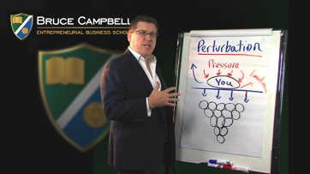

**GENERALISED PRINCIPLE 5:**

**PERTURBATION**

Before starting this section, please Click this Link and watch: <https://youtu.be/SJgiF6a2few>

## Perturbation is a scientific principle about your comfort zone and what you do when you come across obstacles and your ability to push past them. The reality is that you will feel perturbation throughout your career.

## Question: What are you going to do when perturbation shows up?

____________________________________________________________________

____________________________________________________________________

____________________________________________________________________

____________________________________________________________________  
____________________________________________________________________

____________________________________________________________________

## Question: What are some goals you’d like to set but feel they are outside of your comfort zone?

____________________________________________________________________

____________________________________________________________________

____________________________________________________________________

**CONGRATULATIONS ON FINISHING**

**THE WORKBOOK**

Have you done the following? (Please tick)

* Gone over your notes?
* Answered all the questions in this workbook, your goals and signed them off?



Signed…………………………………………….. Date…………………….